**Nov 2014 SL P1**

**Section A**

1. State **one** example of application software. [1]
2. Identify **two** methods that can be used to prevent data loss. [2]
3. Identify **two** methods of providing user documentation. [2]
4. Outline the need for higher level languages. [2]
5. The contents of a 12-bit register is represented in hexadecimal as A5F.
6. State its binary representation. [1]
7. State how many different integers can be represented in this register. [1]
8. Construct a logic diagram for the Boolean expression

A and B or not B. [3]

1. When the wages for company employees are calculated, all hours above 38 are paid at   
   the overtime rate of 1.5 times the base rate.

Construct a flowchart that represents this algorithm. [3]

1. 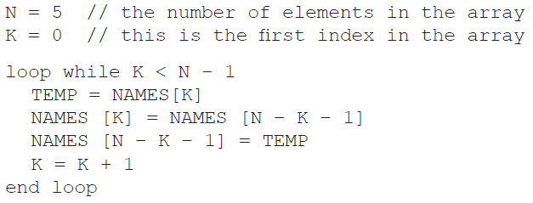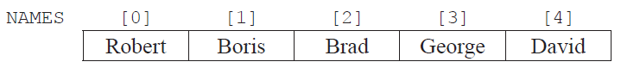Consider the following array  
     
     
     
     
   and the following algorithm, which is constructed to reverse the contents of the array NAMES.
2. Trace the algorithm, showing the contents of the array after each execution of the loop. [2]
3. Identify the type of error that occurs. [1]
4. Outline why the error occurs and how it could be corrected. [2]
5. (a) Outline the differences between a LAN and a VLAN. [3]

(b) Identify **two** factors that should be considered when selecting transmission media. [2]

**Section B**

1. The temperature of a lake for one day is recorded every hour and data is stored in a one-dimensional array named TEMPDAY.

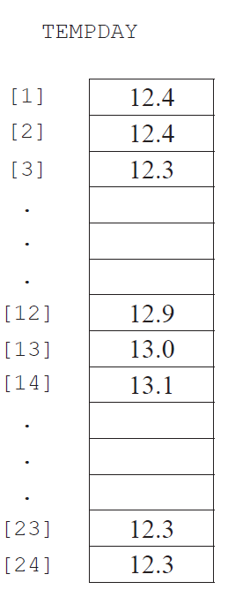

1. State the temperature of the lake at noon. [1]
2. Construct an algorithm that will calculate and output the average temperature. [4 ]
3. Construct an algorithm to find and output the minimum and maximum   
   temperatures for the day. [7]
4. (i) Describe how a two-dimensional array could be used to hold temperature measured  
    every hour, every day for one week. [2]  
     
     
     
     
   (ii) Outline how the temperature on Thursday at 5pm can be accessed. [1]
5. A business has decided to replace their current computer system with a new computer system.
6. Identify **three** examples of how employees, as users of the computer system,   
   may participate in the development of the new system. [3]
7. One method of conversion from the old computer system to the new computer   
   system is parallel running.
8. Define the term parallel running. [1]
9. Identify **one** other method of conversion. [1]
10. Compare parallel running with the method of conversion identified in part (ii). [4]
11. The data from the old computer system needs to be transferred onto the new computer system.   
    Discuss **two** problems that may arise as a result of this data migration. [6]
12. 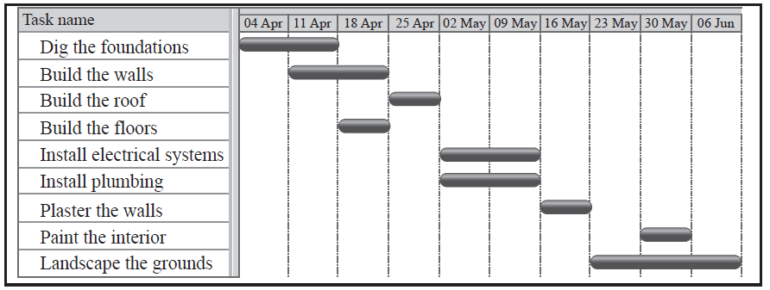Señor Rodriguez is having a new house built and will require local tradesmen to complete  
    a number of tasks.  
      
    The Gantt chart below shows the tasks involved in the building of the house.
13. Define the term concurrent processing. [1]
14. Identify **two** tasks that are carried out concurrently. [1]
15. Identify **two** tasks that are carried out sequentially. [1]
16. Describe how the idea of abstraction applies to one of the tasks. [2]
17. Explain **one** advantage and **one** disadvantage of carrying out a number  
    of tasks concurrently. [4]

Amalia Rodriguez, his daughter, is a student and is completing her homework.   
 This requires her to view web pages, edit a document, and print out draft copies.

However, she is also surfing the web, keeping up to date on her social networking  
 site as well as downloading apps and music from a P2P site.

1. For one of the application programs which she uses to perform these activities,  
   outline one task that is carried out by the application program itself. [2]

Within the application the graphical user interface (GUI) elements are reliant on the   
 operating system.

1. Identify two GUI components that are common to all of the above and are carried  
   out by the operating system. [2]
2. Outline how the use of abstract GUI components simplifies application programming. [2]